**Bài tập ngày 5.5**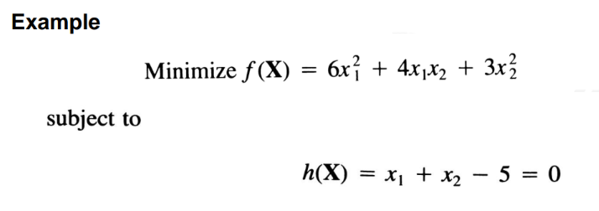

Câu 1:

Câu 2

minimize f(x) = 5x1^2 + 3x1x2 + x2^2

subject to h(X)= x1 + x2 -3 =0

**CODE:**

#include <iostream>

#include <iomanip>

#include <cmath>

using namespace std;

double a, b, c, d;

double f(double x1, double x2) {

return a * x1 * x1 + b * x1 * x2 + c * x2 * x2;

}

double tinhX2(double rk, double lambda) {

return (20 * rk - 2 * lambda) / (14 - 5 * rk);

}

double tinhX1(double rk, double lambda) {

double denominator = (14 - 5 * rk) * (12 + 2 * rk);

double numerator = -90 * rk * rk + 9 * rk * lambda - 6 * lambda + 60 * rk;

return numerator / denominator;

}

double tinhHx(double x1, double x2) {

return x1 + x2 - d;

}

void inKetQua(int k, double lambda, double rk, double x1, double x2, double hx) {

cout << setw(3) << k

<< setw(12) << lambda

<< setw(10) << rk

<< setw(12) << x1

<< setw(12) << x2

<< setw(14) << hx << endl;

}

int main() {

cout << "Nhap he so a, b, c trong f(x1,x2) = a*x1^2 + b*x1*x2 + c*x2^2:\n";

cin >> a >> b >> c;

cout << "Nhap d trong rang buoc x1 + x2 = d:\n";

cin >> d;

double lambda = 0.0;

double rk = 1.0;

double epsilon = 1e-5;

int maxIterations = 30;

cout << fixed << setprecision(5);

cout << setw(3) << "k"

<< setw(12) << "lambda(k)"

<< setw(10) << "r_k"

<< setw(12) << "x1(k)"

<< setw(12) << "x2(k)"

<< setw(14) << "h(k)" << endl;

for (int k = 1; k <= maxIterations; ++k) {

double x2 = tinhX2(rk, lambda);

double x1 = tinhX1(rk, lambda);

double hx = tinhHx(x1, x2);

inKetQua(k, lambda, rk, x1, x2, hx);

if (fabs(hx) < epsilon) {

cout << "\nKet qua gan dung:\n";

cout << "x1 = " << x1 << ", x2 = " << x2 << ", f(x) = " << f(x1, x2) << endl;

return 0;

}

lambda += 2 * rk * hx;

}

cout << "\nKhong hoi tu sau " << maxIterations << " buoc lap.\n";

return 0;

}

